Physics 122
Hour Exam 3

Instructions:

- You have two hours to complete this exam.
- You may do any required work in the test booklet, but you must place your final answer on the Scantron to receive credit.
- Place your name and test number on your Scantron.

You have test number 1

- There are two different types of problems on this exam.
- Problems with three possible answers are worth 3 points each.
- Problems with five possible answers are worth 6 points each.

Name ________________________

Section ______________________

The next five questions are about the following situation:

1. Which ray(s) in the following diagram is(are) wrong?

(A) A
(B) B
(C) C
(D) D
(E) B and C

2. Where would the image be formed in the picture above?

(A) To the left of the left focal point.
(B) Between the left focal point and the lens.
(C) Between the right focal point and the lens.
(D) To the right of the right focal point.
(E) At the right focal point.

3. The image formed by the lens configuration in problem 1 is:

(A) Upright
(B) Inverted
(C) Inappropriate

4. The image formed by the lens configuration in problem 1 is:

(A) Real
(B) Virtual
(C) Republican

5. The image formed by the lens configuration in problem 1 is:

(A) Larger
(B) Smaller
(C) Colorful

6. Light of wavelength 650 nm is incident on a double slit with a slit spacing of 1cm. Each slit has a slit width of 0.333cm. The distance between the slits and the screen is
3.2 m. In the interference pattern, what is the width of the central bright fringe?

(A) 1.9x10⁻³ m
(B) 2.1x10⁻⁴ m
(C) 1.6x10⁻⁵ m
(D) 3.2x10⁻⁶ m
(E) 2.9x10⁻⁸ m

7. How far from the center of the interference pattern is the ninth order bright fringe?

(A) 1.9x10⁻³ m
(B) 2.1x10⁻⁴ m
(C) 1.6x10⁻⁵ m
(D) 3.2x10⁻⁶ m
(E) 2.9x10⁻⁸ m

8. Which order bright fringe in the interference pattern is the first that is missing?

(A) 1
(B) 2
(C) 3
(D) 4
(E) 5

9. If the frequency of light emitted from a distant star is ƒ_{s} = 4.5x10¹⁴ Hz. and the frequency of light that we observe coming from that start is ƒ_{o} = 4.7x10¹⁴ Hz. What is the speed of the star with respect to earth?

(A) 1.33 x10⁷ m/s
(B) 1.87 x10⁷ m/s
(C) 2.43 x10⁷ m/s

10. When you look at your upright reflection in a concave (converging) mirror, the image you see is:

(A) real
(B) virtual
(C) inverted

11. Rainbows occur when light undergoes _______________ in water droplets.

(A) refraction only
(B) interference only
(C) total internal reflection and interference
(D) total internal reflection and refraction
(E) refraction and interference

The next three questions are about the following situation:
An object is placed in front of a convex mirror as shown.

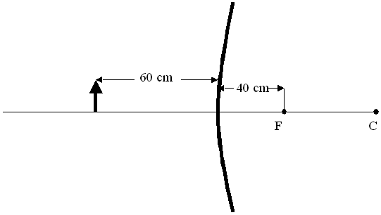
12. Where will the image be located with respect to the mirror?

(A) In front of the mirror
(B) Behind the mirror
(C) There is no image formed by the mirror

13. What is the magnification, M, of the mirror for the object placed as shown?

(A) -0.2
(B) -2.5
(C) 0.4
(D) 2.5
(E) 4.0

14. The image formed by the mirror is:

(A) Upright and virtual
(B) Upright and real
(C) Inverted and virtual
(D) Inverted and real
(E) Worth some money on Ebay

The next three questions are about the following situation:
An unpolarized electromagnetic wave is incident at a series of three linear polarizers, each with the polarization angle rotated at 45° with respect to the previous one.
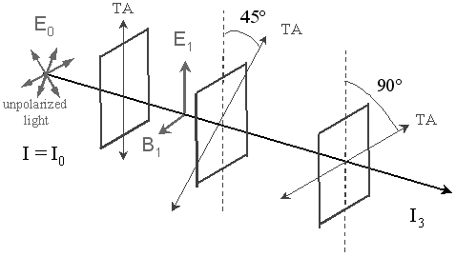
15. If the initial intensity of the unpolarized light is I₀, what is the intensity I₁ transmitted by the first polarizer?

(A) I₁ = I₀
(B) I₁ = 3I₀/4
(C) I₁ = I₀/2
(D) I₁ = I₀/4
(E) I₁ = I₀/8

16. If the initial intensity of the unpolarized light is I₀, what is the intensity I₃ transmitted by all three polarizers?

(A) I₃ = I₀
(B) I₃ = I₀/4
(C) I₃= I₀/8
(D) I₃= I₀/10
(E) I₃ = I₀/16

17. If the angle of the second polarizer with respect to the vertical (dotted line) was increased to 60⁰ the intensity transmitted by all three polarizers (as compared to the answer from number 16) would:

(A) Increase

(B) Decrease

(C) Remain the same

18. If the angle of the second polarizer with respect to the vertical (dotted line) was decreased to 30⁰ the intensity transmitted by all three polarizers (as compared to the answer from number 16) would:

(A) Increase

(B) Decrease

(C) Remain the same

19. At what angle from the normal would total internal reflection occur between air

n =1.0 and water n = 1.3?

(A) 30º

(B) 50º

(C) 60º

20. Total internal reflection would occur for air and water if the light was:

(A) In the air

(B) In the water

(C) Faster

The next two questions are about the following situation:

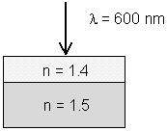
Red light (λ = 600 nm in air) travels from air (n=1) into a thin plastic film (n=1.4), which is on top of a thick glass plate (n=1.5).

21. Find t, the minimum (non-zero) thickness of the film, which gives destructive interference

(A) t = 0.83 nm
(B) t = 107 nm
(C) t = 234 nm
(D) t = 367 nm
(E) t = 637 nm

22. If the thickness of the plastic film were doubled, the red light would interfere

(A) Constructively

(B) Destructively

(C) Neither

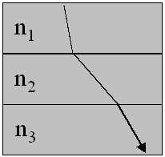
23. A light beam travels from material 1 to 2 to 3 along the path shown in the figure above. From this picture, you can conclude that:

(A) n₁ < n₂ < n₃

(B) n₁ < n₃ < n₂

(C) n₂ < n₃ < n₁

The next two questions are about the following situation:
An object is placed between the center of curvature, C, and the focal point, F, of a concave mirror. Use ray-tracing techniques to locate the image.
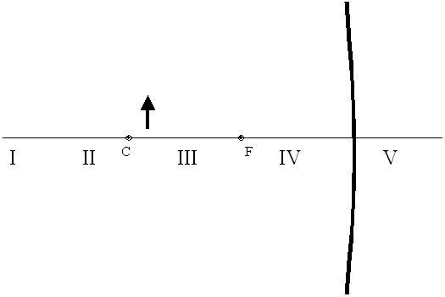

24. The image will be found closest to:

A) I B) II C) III D) IV E) V

25. The image is

(A) virtual and erect
(B) virtual and inverted
(C) real and inverted
(D) real and erect
(E) condescending

26. Two converging lenses (f₁ = 9.00cm and f₂ = 6.00cm) are separated by 18.0cm. The lens on the left has the longer focal length. And object stands 12.0cm to the left of the lens on the left. Where is the final image located relative to the right lens?

(A) 4.5 cm to the left
(B) 10 cm to the left
(C) 20 cm to the left
(D) 4.5 cm to the right
(E) 10 cm to the right

The next three questions concern the same physical situation.
A series LRC circuit contains the following components as shown in the picture. The components are connected to an alternating voltage source with a frequency of 500 Hz.
F=500 Hz
C= 10 μF
R= 10 Ω
L = 40 mH

27. In this circuit compare the voltage to the current.

A) The voltage is leading the current.
B) The voltage is lagging the current.
C) The voltage is in phase with the current.

28. What is the impedance of the circuit?

A) Z = 15.6 Ohms
B) Z = 54.2 Ohms
C) Z = 94.3 Ohms
D) Z = 101.4 Ohms
E) Z = 306.9 Ohms

29. If the frequency of the voltage source was increased the rms value of the current flowing in the circuit would:

A) Increase
B) Decrease
C) Remain the same

A series LRC circuit is comprised with the following components as shown in the picture below. The circuit is connected to an alternating voltage source, which is operating at the resonant frequency of the circuit. An ammeter is placed in the circuit and the maximum current is measured to be 0.25 Amps.
V
C= 12 μF
R= 40 Ω
L = 20 mH

30. What is the maximum voltage supplied by the voltage source?

A) 10 V
B) 12 V
C) 20 V
D) 25 V
E) 30 V

31. What is V_{Cmax}, the maximum voltage across the Capacitor?

A) 10.2 V
B) 12.6 V
C) 18.3 V
D) 21.4 V
E) 24.9 V

32. How much power is being supplied by the voltage source?

A) 1.25 W
B) 3.13 W
C) 11.3 W
D) 15.4 W
E) 21.9 W

Electrostatics
F = ma
F = kq₁q₂/r²
k = 1/4πε₀
E = F/q_{o}
E = kq/r² (point charge)
W_{AB} = EPE_{A} – EPE_{B}
V = EPE/q_{o}
V_{B} – V_{A} = -W_{AB}/q_{o}
V = kq/r (point charge)
q = CV
Energy = ½ qV = ½ CV² = q²/2C
Energy density =1/2∈_{o}E²

Circuits
C_{P} = C₁ + C₂ + ...
1/C_{s} = 1/C₁ + 1/C₂ + ...
I = Δq/Δt
V = IR (Resistor)
R = ρL/A (Resistance)
P = IV (Power)
R_{S} = R₁ + R₂ + ...
1/R_{P} = 1/R₁ + 1/R₂ + ...
q = q_{o}[1-e^{-t/RC}] (Charging)
q = q_{o}e^{-t/RC} (Discharging)

Magnetism
F = q_{o}vBsinθ (force on moving charge)
F = ILBsinθ (force on wire)
τ = NIAB sinφ (torque on loop)
B = μ_{o}I/2πr (wire)
B = Nμ_{o}I/2R (loop)

B = μ_{o}nI (solenoid)
Φ = BA cosφ (flux)
E = -NΔΦ/Δt (Induced emf)
ω = 2πf
Energy = ½ LI² (Inductor)
Energy density = 1/(2μ_{o}) B²
r = mv/qB (radius of particle in Bfield)

AC Circuits
V_{s}/V_{p} = Ns/Np (Transformer)
I_{rms} = I_{MAX}/√2
V_{rms} =V_{MAX}/√2

X_{C} = 1/(2πfC) (Reactance)
X_{L} = 2πfL (Reactance)
V = IZ (Generator)
V = I X_{L} (Inductor)
V = I X_{C} (Capacitor)
Z = (R² + (X_{L} - X_{C})²)^{1/2}
f_{o} = 1/(2π√LC) (Resonance)
P = I²_{rms} R (Power)

Phase angle
tan φ = (X_{L} - X_{C})/R = (V_{L} - V_{C})/V_{R}
cos φ = V_{R}/V_{o}
sin φ = (V_{L} - V_{C})/V_{o}

E&M Waves
c = fλ (Wave equation)
I = I_{o} cos²θ (Polarization)
f’ = f(1⁺/- v/c) (Doppler effect)

Lenses and Mirrors
1/f = 1/d_{o} + 1/d_{i}
m = h_{i}/h_{o} = -d_{i}/d_{o}
n₁sinθ₁ = n₂sinθ₂ (Snell’s Law)
sin θ_{c} = n₂/n₁ (Critical angle)
tan θ_{b} = n₂/n₁ (Brewster’s angle)
v = c/n
Interference
l₂-l₁= (m+1/2)λ (Destructive)
l₂-l₁= mλ (Constructive)
Double Slit
sin θ = mλ/d (Bright)
sin θ = (m+1/2)λ/d (Dark)
Thin Film
l₂-l₁ = 2t
λ_{film} = λ_{vac}/n_{film}
n₁ < n₂ (1/2 λ phase shift)
Single slit/Diffraction
sinθ = m λ/W (Dark) (single)
sinθ = m λ/d (Bright) (diff.)

Constants
k = 8.99x10⁹ Nm²/C²
ε₀ = 8.85x10⁻¹² C²/Nm²
e = 1.60x10⁻¹⁹ C
μ_{o} = 4π x10⁻⁷ Tm/A
c = 3x10⁸ m/s
h = 6.62 x10⁻³⁴ J*s
m_{e} = 9.109 x10⁻³¹ kg
m_{p} = 1.672 x10⁻²⁷ kg
1 eV = 1.6 x 10⁻¹⁹ J

