The next two questions concern the same physical situation.
Three very long wires each carrying the same current out of the page are positioned at the corners of a square as shown.
I₂
I₁
I₃
a

1. The Magnetic field produced by the three wires at the center of the square (point a) points:

A) Toward wire I₁
B) Toward wire I₂
C) Toward wire I₃
D) Out of the page
E) Into the page

2. If the current flowing in each wire is 3A, the length of each wire is 10m, and the length of each side of the square is 2m, what is the magnitude of the net force on I₂ from the other two wires?

A) 1.27 x 10⁻⁵ N
B) 1.59 x 10⁻⁵ N
C) 2.24 x 10⁻⁵ N
D) 2.86 x 10⁻⁵ N
E) 3.24 x 10⁻⁵ N

A solenoid with cross sectional area A = 4x10⁻⁴ m² is .120 m long and has 2500 turns. The magnetic field at the center of the solenoid is 5 × 10⁻³ T pointing into the page. A square wire loop 1.5 cm on each side is fixed inside the solenoid as shown.
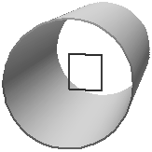
3. What is the magnitude and direction of the current through the coils of the solenoid?

A) 0.19 A Clockwise
B) 0.67 A Clockwise
C) 2.24 A Counterclockwise
D) 2.86 A Counterclockwise
E) 3.24 A Counterclockwise
Continued from previous page

4. What is the magnitude of the flux in the square loop.

A) 1.125 x 10⁻⁶ Wb
B) 1.594 x 10⁻⁶ Wb
C) 2.246 x 10⁻⁶ Wb
D) 2.862 x 10⁻⁶ Wb
E) 3.240 x 10⁻⁶ Wb

5. The current in the solenoid is uniformly decreased to zero over 10 seconds. What is the magnitude of the induced emf in the square loop?

A) 1.125 x 10⁻⁷ V
B) 1.259 x 10⁻⁷ V
C) 2.124 x 10⁻⁷ V
D) 2.486 x 10⁻⁶ V
E) 1.124 x 10⁻⁶ V

The next two questions concern the same physical situation.
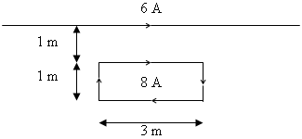
A rectangular current loop is located near a long, straight wire that carries a current of 6 A flowing to the right (see the figure). The current in the loop I_{loop} = 8 A is flowing clockwise.

6. The net force on the loop is:

A) Up
B) Down
C) Zero

7. The magnitude of the net force on the side of the rectangle that is parallel to and closest to the wire is:

A) 0 N
B) 2.9 x 10⁻⁵ N
C) 6.3 x 10⁻⁵ N
D) 8.4 x 10⁻⁵ N
E) 12.6 x 10⁻⁵ N
The next three questions concern the same physical situation.
A series LRC circuit contains the following components as shown in the picture. The components are connected to an alternating voltage source with a frequency of 50 Hz.
F=50 Hz
C= 10 μF
R= 10 Ω
L = 40 mH

8. In this circuit compare the voltage to the current.

A) The voltage is leading the current.
B) The voltage is lagging the current.
C) The voltage is in phase with the current.

9. What is the impedance of the circuit?

A) Z = 15.6 Ohms
B) Z = 94.2 Ohms
C) Z = 143 Ohms
D) Z = 253 Ohms
E) Z = 306 Ohms

10. If the frequency of the voltage source was increased the rms value of the current flowing in the circuit would initially:

A) Increase
B) Decrease
C) Remain the same

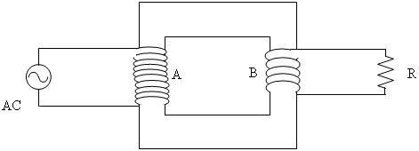
11. The figure to the right shows wires wrapped around an iron core. Coil A has 10 turns, and coil B has 5 turns. This serves as an ideal transformer between an AC generator and a resistor. The resistance R = 9 Ω. The average power dissipated in the resistor is P = 90 W
What is the V_{rms} of the generator?

A) V_{rms}= 12.4 V
B) V_{rms}= 32.3 V
C) V_{rms}= 56.9 V

The next four problems concern the following situation

A series LRC circuit is comprised with the following components as shown in the picture below. The circuit is connected to an alternating voltage source, which is operating at the resonant frequency of the circuit. An ammeter is placed in the circuit and the maximum current is measured to be 0.25 Amps.
V
C= 15 μF
R= 75 Ω
L = 45 mH

12. What is the maximum voltage supplied by the voltage source?

A) 10.4 V
B) 12.1 V
C) 18.8 V
D) 24.3 V
E) 31.3 V

13. What is V_{Lmax}, the maximum voltage across the Inductor?

A) 10.2 V
B) 13.7 V
C) 19.3 V
D) 20.1 V
E) 22.4 V

14. How much power is being supplied by the voltage source?

A) 1.13 W
B) 1.72 W
C) 2.34 W
D) 5.42 W
E) 7.93 W

15. What is the phase angle, φ, of this circuit?

A) φ = 0º
B) φ = 21.2º
C) φ = 35.4º
D) φ = 62.7º
E) φ = 90º
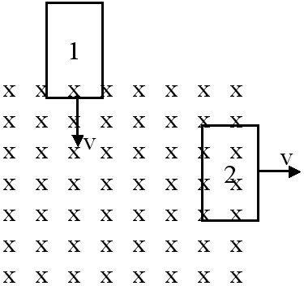
The next three problems concern the following situation
Two loops with the same area and resistance are moving with respect to a region of uniform magnetic field (indicated by the X’s). They are moving with equal speed, but loop number 1 is traveling down and loop number 2 is traveling to the right. Answer the following questions based on the position of the loops as they are shown. (Both loops are partially inside and outside of the area containing the magnetic field)

16. At the instant shown, compare the flux in loop 1, Φ₁, to the flux in loop 2, Φ₂.
A) Φ₁ < Φ₂
B) Φ₁ = Φ₂
C) Φ₁ > Φ₂

17. At the instant shown, compare the magnitude of the induced current in the two loops.
A) I₁ < I₂
B) I₁ = I₂
C) I₁ > I₂

18. The current in loop 1 is flowing ____________ and the current in loop 2 is flowing ___________.

A) clockwise, clockwise
B) clockwise, counter-clockwise
C) counter-clockwise, clockwise
D) counter-clockwise, counter-clockwise
E) There is not enough information given

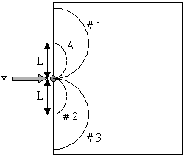
The next four problems concern the following situation
Two particles, A (m_{A}=1.7 ×10⁻²⁷ kg ,
Q_{A}= 1.6 × 10⁻¹⁹ C ) and B (m_{B}= 3.4 × 10⁻²⁷ kg,
Q_{B}= -3.2 × 10⁻¹⁹ C ) enter a box with uniform magnetic field B= 6 T. Particle A enters with velocity v =2x10⁸ m/s and follows trajectory A.

19. Which direction is the B field pointing?

A) Up
B) Down
C) Right
D) Into the page
E) Out of the page

20. If particle B enters the region with twice as much velocity as particle A, which path will it take?

A) #1
B) #2
C) #3

21. What is the length L?

A) 0.18 m
B) 0.71 m
C) 1.05 m
D) 1.67 m
E) 2.50 m

22. What is the velocity of Particle B when it leaves the region of magnetic field?

A) 2.6x10⁸ m/s
B) 4.0x10⁸ m/s
C) 5.2x10⁸ m/s
D) 1.6x10⁹ m/s
E) 2.0x10⁹ m/s

